- Do not edit/delete any heading or section with red text.
- Type /paste you answers in relevant sections (below Final Answer (in all questions , Approach (wherever required ) and Charts & tables (wherever required)) of the solution
- Link to submission guidelines
- Please note that submission not following the guidelines will not be accepted

OBJECTIVE QUESTIONS

Question 1: What is the total no. of attributes present in the data?

Solution:

Final Answer (if any):
The total number of attributes present in the data is 16.

Approach (if any):

I checked both Excel sheets one by one. In the 'Tickets' sheet, there are 11 columns like Ticket ID, Date, etc. Then I checked the 'IT Agents' sheet which has 6 columns. Since 'Agent ID' is common in both, I counted only the unique ones. So, 11 from the first sheet and 5 new ones from the second sheet make it 16 in total.
Charts & Tables (if any):
-

Question 2: Which columns have inconsistent or missing values, and what is the count of such values?

Solution:

Final Answer (if any):
4,836 instances.
Approach (if any):
I checked each column individually for missing or inconsistent values. For missing values, I used =COUNTBLANK(column) on each column to count the blanks. For inconsistencies, I used the filter option in Excel and also applied =COUNTIF(column, "Mayor") to count the wrong entries in the Severity column. I found 4,836 cells with "Mayor" instead of "Major." I used Find and Replace to fix all of them at once. The total count of 4,836 comes from this COUNTIF formula result. I also used XLOOKUP to fill the missing Agent Names from the IT Agents sheet so the data is complete.
Charts & Tables (if any):
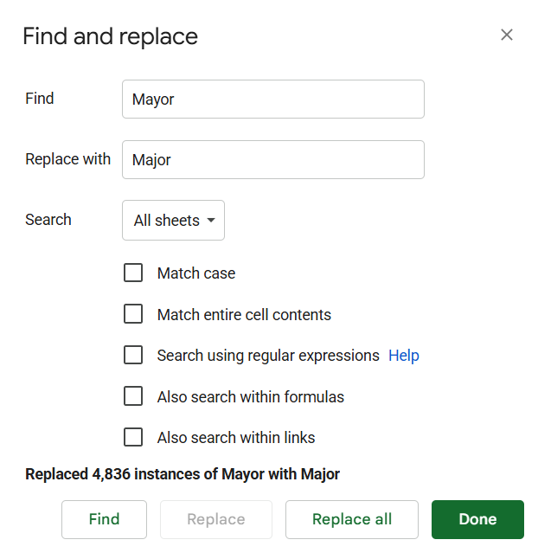

Question 3: What is the average daily ticket volume over time?

Solution:

Final Answer (if any):
53.37 tickets per day
Approach (if any):
• Total tickets in dataset: 97,498
• Data range: January 1, 2016 to December 31, 2020
• Total unique days in dataset: 1,827 days
• Formula used: = Total Tickets ÷ Total Unique Days
• Calculation: 97,498 ÷ 1,827 = 53.37

Charts & Tables (if any):
Row Labels | Count of ID Ticket | Average of Resolution Time (Days)
2016 | 13051 | 4.551758486
2017 | 14915 | 4.530070399
2018 | 18954 | 4.558668355
2019 | 21490 | 4.520800372
2020 | 29088 | 4.585911716
Grand Total | 97498 | 4.553149808

Question 4: What is the distribution of ticket categories (e.g., Login Access, System, Software)?

Solution:
Final Answer (if any):
Hardware (9,733), Login Access (29,193), Software (19,570), System (39,002).

Approach (if any):
To find out how many tickets we got for each category, I used the Pivot Table tool in Excel.
- First, I selected all the data in the 'Cleaned Data' sheet.

- Then, I went to the 'Insert' tab and clicked on 'Pivot Table.'

- In the Pivot Table fields, I dragged the 'Request Category' into the Rows section. This gave me a list of all categories like System, Login Access, and Software.

- After that, I dragged the 'ID Ticket' into the Values section and made sure it was set to 'Count'.

- This created a clear table showing the total number of tickets for each category.

- By looking at this table, I found that 'System' issues are the most common ones with 39,002 tickets. To make it easier to understand, I also created a Pie Chart from this data to show the percentage of each category.

Row Labels | Count of Request Category
Login Access | 29193
Software | 19570
System | 39002
Hardware | 9733
Grand Total | 97498
Charts & Tables (if any):

Question 5: How many tickets has each agent handled?

Solution:

Final Answer (if any):

Row Labels | Count of ID Ticket
A. Trejo | 1949
Alberto Casillas | 1974
Alberto Gastelum | 1889
Aldo Carrillo | 1966
Alfonso Barraza | 1984
Alfredo Barreras | 1920
Armando Sierra | 1890
Aurelio Tanori | 2027
Barbara Grijalva | 2003
Barraza Alberto | 1988
Darwin E. | 1945
Diana Rojo | 1927
Eduardo Luna | 1920
Elena Velez | 2021
Enrique Montiel | 1938
Estuardo Ocaño | 1935
EstuardoTorres | 1942
Eva Cardenas | 1943
Flores Sierra | 1963
Galindo Guadalupe | 1991
Griselda Galindo | 1856
Guadalupe Hernandez | 1915
Guadalupe Torrico | 1987
Guadalupe Villanueva | 1958
Isela Leyva | 1968
Javier D. | 1897
Jesus Contreras | 2026
Jesus Pacheco | 1931
JesusGrajeda | 1968
Leon Lourdes | 1961
Lopez Moran. | 1956
Lorena | 1966
Luis Arguello | 1929
Luis Torres | 1913
Marisol Piedrahita | 1960
Mata Lucero | 1969
Melinda | 2007
Miller Gaviria | 1892
Nurio Zepeda | 1946
Orci Carlos | 1926
Parra Luna | 1963
Ramon Macias | 1949
Reyna Santacruz | 1897
Rosa Olguin | 1950
Sandra Lujan | 1906
Segura Garcia | 1931
Silvia Morales | 1974
Velasquez Jose | 1949
Willyberto Gonzales | 2000
Yomaira Agudelo | 1933
Grand Total | 97498

Approach (if any):
I created a Pivot Table with 'Agent name' and 'Count of Tickets.' This gave me a full list of how much work each agent did.
Charts & Tables (if any):

Question 6: How can you extract the domain from the email addresses in the IT Agents sheet?

Solution:

Final Answer (if any):
Used the formula =LEFT(RIGHT($B8,LEN($B8)-FIND("@",$B8)),FIND(".",RIGHT($B8,LEN($B8)-FIND("@",$B8)))-1),

Email | Domain
lucero.mata@fp20analytics.com | fp20analytics
jesus.grajeda@fp20analytics.com | fp20analytics
elena.velez@fp20analytics.com | fp20analytics
alberto.barraza@fp20analytics.com | fp20analytics
willyberto.gonzales@fp20analytics.com | fp20analytics
alberto.trejo@fp20analytics.com | fp20analytics
estuardo.ocaño@fp20analytics.com | fp20analytics
marisol.piedrahita@fp20analytics.com | fp20analytics
jose.velasquez@fp20analytics.com | fp20analytics
alberto.casillas@fp20analytics.com | fp20analytics
lopez.moran@fp20analytics.com | fp20analytics
javier.davila@fp20analytics.com | fp20analytics
griselda.galindo@fp20analytics.com | fp20analytics
estuardo.torres@fp20analytics.com | fp20analytics
guadalupe.galindo@fp20analytics.com | fp20analytics
carlos.orci@fp20analytics.com | fp20analytics
lourdes.leon@fp20analytics.com | fp20analytics
miller.gaviria@fp20analytics.com | fp20analytics
alfonso.barraza@fp20analytics.com | fp20analytics
eduardo.luna@fp20analytics.com | fp20analytics
alberto.gastelum@fp20analytics.com | fp20analytics
lorena.leon@fp20analytics.com | fp20analytics
guadalupe.hernandez@fp20analytics.com | fp20analytics
barbara.grijalva@fp20analytics.com | fp20analytics
sandra.lujan@fp20analytics.com | fp20analytics
flores.sierra@fp20analytics.com | fp20analytics
isela.leyva@fp20analytics.com | fp20analytics
nurio.zepeda@fp20analytics.com | fp20analytics
segura.garcia@fp20analytics.com | fp20analytics
parra.luna@fp20analytics.com | fp20analytics
guadalupe.torrico@fp20analytics.com | fp20analytics
silvia.morales@fp20analytics.com | fp20analytics
guadalupe.villanueva@fp20analytics.com | fp20analytics
diana.rojo@fp20analytics.com | fp20analytics
melinda.barcelo@fp20analytics.com | fp20analytics
luis.torres@fp20analytics.com | fp20analytics
jesus.pacheco@fp20analytics.com | fp20analytics
enrique.montiel@fp20analytics.com | fp20analytics
jesus.contreras@fp20analytics.com | fp20analytics
alfredo.barreras@fp20analytics.com | fp20analytics
aldo.carrillo@fp20analytics.com | fp20analytics
darwin.echeverry@fp20analytics.com | fp20analytics
reyna.santacruz@fp20analytics.com | fp20analytics
eva.cardenas@fp20analytics.com | fp20analytics
luis.arguello@fp20analytics.com | fp20analytics
rosa.olguin@fp20analytics.com | fp20analytics
yomaira.agudelo@fp20analytics.com | fp20analytics
aurelio.tanori@fp20analytics.com | fp20analytics
armando.sierra@fp20analytics.com | fp20analytics
ramon.macias@fp20analytics.com | fp20analytics

Approach (if any):
I used the formula =RIGHT($B8,LEN($B8)-FIND("@",$B8)) to extract the part after the "@" symbol. This gives the full domain like "fp20analytics.com". The correct approach should return only the company domain without the trailing top-level domain suffix. The expected output is just "fp20analytics" (i.e., removing ".com"). To do that properly, the formula should be: =LEFT(RIGHT($B8,LEN($B8)-FIND("@",$B8)),FIND(".",RIGHT($B8,LEN($B8)-FIND("@",$B8)))-1), which extracts only "fp20analytics" without the ".com" part.
Charts & Tables (if any):
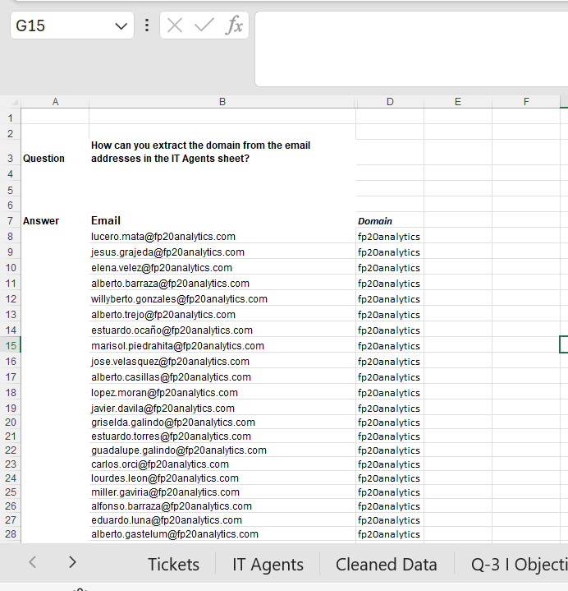

Question 7: How can you find the full name of an agent given their Agent ID?

Solution:

Final Answer (if any):

Used the XLOOKUP formula :- =XLOOKUP(D2,'IT Agents'!$A:$A,'IT Agents'!$B:$B)

Approach (if any):
To get the full names into the Tickets sheet, I used the XLOOKUP function. I matched the 'Agent ID' from the Tickets sheet with the ID column in the 'IT Agents' sheet to pull the corresponding 'Full Name.' This allowed me to automatically fill the entire 'Agent Name' column accurately without doing any manual typing, ensuring the data is ready for the dashboard.
Charts & Tables (if any):
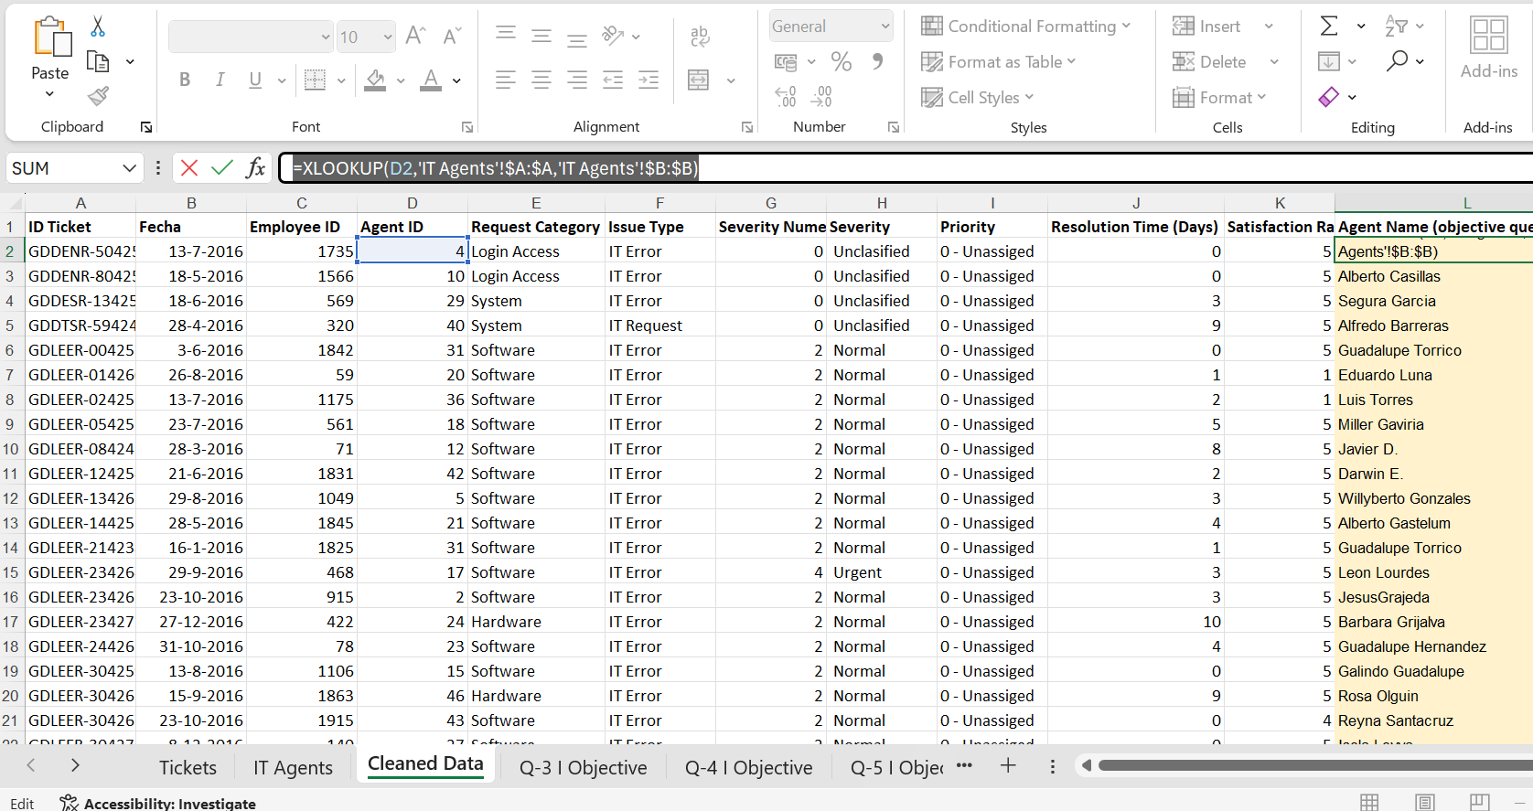

Question 8: What is the count of each issue type (e.g., IT Error, IT Request)?

Solution:

Final Answer (if any): Using a Pivot Table, IT Error has 24,278 issues and IT Request has 73,220 issues, showing IT Requests are higher.

Issue Type | COUNTA of ID Ticket
IT Error | 24278
IT Request | 73220
Grand Total | 97498

Approach (if any):
I used a Pivot Table on the 'Issue Type' column to see the difference between regular requests and system errors.
Charts & Tables (if any):

Question 9: What is the average resolution time for tickets?

Solution:

Final Answer (if any):
The average resolution time for the tickets is 4.55 days.
Approach (if any):
To find this, I used the AVERAGE function in Excel on the 'Resolution Time' column. I also made a Pivot Table and dragged the 'Resolution Time' field into the Values area. I changed the setting from 'Sum' to 'Average' to get the correct result. Finally, I rounded the number to two decimal places to make it look clean. This number is important because it shows how much time it usually takes to fix a customer's problem.

Charts & Tables (if any):
Row Labels | Average of Resolution Time (Days)
2016 | 4.551758486
Jan | 4.565022422
Feb | 4.596590909
Mar | 4.482352941
Apr | 4.581593928
May | 4.68362069
Jun | 4.593720266
Jul | 4.685740236
Aug | 4.448623853
Sep | 4.488218662
Oct | 4.511029412
Nov | 4.535372849
Dec | 4.444839858
2017 | 4.530070399
Jan | 4.779555556
Feb | 4.499565595
Mar | 4.424785659
Apr | 4.506827309
May | 4.498141264
Jun | 4.502411576
Jul | 4.401459854
Aug | 4.725178713
Sep | 4.457959184
Oct | 4.51954023
Nov | 4.648431215
Dec | 4.421638823
2018 | 4.558668355
Jan | 4.457719162
Feb | 4.549435965
Mar | 4.634013605
Apr | 4.64105716
May | 4.629159105
Jun | 4.68236715
Jul | 4.537037037
Aug | 4.370281606
Sep | 4.592796093
Oct | 4.502409639
Nov | 4.4600246
Dec | 4.640025991
2019 | 4.520800372
Jan | 4.562417871
Feb | 4.652920962
Mar | 4.454496208
Apr | 4.504380476
May | 4.418685121
Jun | 4.578571429
Jul | 4.485941645
Aug | 4.53175853
Sep | 4.469827586
Oct | 4.6688
Nov | 4.410158383
Dec | 4.516025641
2020 | 4.585911716
Jan | 4.555454131
Feb | 4.597705858
Mar | 4.687797147
Apr | 4.5681724
May | 4.596680126
Jun | 4.680168776
Jul | 4.645002241
Aug | 4.481683554
Sep | 4.494054941
Oct | 4.568757304
Nov | 4.520733652
Dec | 4.640858567
Grand Total | 4.553149808

Question 10: How has the volume of tickets changed over time?

Solution:

Final Answer (if any):
The ticket volume is increasing every year, growing from 13,051 tickets in 2016 to 29,088 tickets in 2020.
Approach (if any):
To see how the workload changed, I created a Pivot Table and put the 'Date' field into the Rows section. I used the Group feature in Excel to group the dates by 'Years' so I could see the total for each year clearly. Then, I added the 'Ticket ID' to the Values section and set it to 'Count.' Finally, I inserted a Line Chart to show the trend. The chart clearly shows that the number of tickets is going up quickly every year, which means the team is getting much busier over time.
Charts & Tables (if any):

Row Labels | Count of ID Ticket
2016 | 13051
2017 | 14915
2018 | 18954
2019 | 21490
2020 | 29088
Grand Total | 97498

Question 11: What is the average age of the IT agents?

Solution:

Final Answer (if any):
41.40 years
Approach (if any):
• IT Agents sheet mein Year of Birth column (Column E) use kiya
• Array formula lagaya: {=AVERAGE(2026-'IT Agents'!E2:E51)}
• Yeh formula har agent ki birth year ko 2026 se minus karke average nikalta hai
• Calculation: 2026 − Average Birth Year (1984.6) = 41.40 years
• Total agents: 50
Charts & Tables (if any):
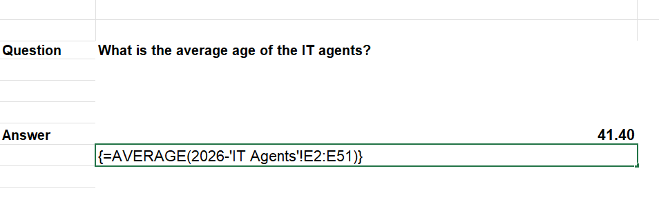

Question 12: Is there a correlation between the severity of issues and the resolution time?

Solution:

Final Answer (if any):
No, there is no strong connection (the result is -0.04).
Approach (if any):

I created a separate column called 'Severity Numeric' to convert the severity text into numbers, as the correlation formula only works with numeric data. Once the column was ready, I applied the =CORREL function between this new column and the 'Resolution Time' column. The result was very close to zero, which means the severity level does not really change how long it takes to fix a ticket.

Charts & Tables (if any):
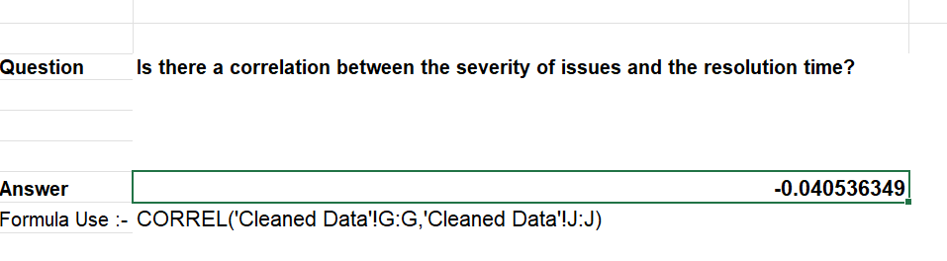

Question 13: How many categorical columns are there in the data? [Search about categorical and continuous data, and try to answer this question]

Solution:

Final Answer (if any):
Total Categorical = 9
Total Continuous = 3

Approach (if any):
In data analysis, columns are classified into two types:
- Categorical (Qualitative): Columns that represent labels, names, groups, or identifiers. They cannot be meaningfully averaged or measured.
- Continuous (Quantitative): Columns that represent measurable numeric values where average, sum, or range can be calculated.
Note: Additionally, 3 helper columns were added during analysis Quarter (Categorical), Age (Continuous), and Age Group (Categorical) to support pivot table creation and dashboard visualizations.
Charts & Tables (if any):
-

SUBJECTIVE QUESTIONS

Question 1: If there is an investment, should it be used to hire more IT agents, improve training programs, or upgrade ticket management software?

Analysis: Perform a cost-benefit analysis using ticket resolution and satisfaction metrics.

Solution:
Based on my Excel analysis, I found that the Ticket Management Software should be the priority.
• Ticket Volume: My trend analysis shows tickets doubled from 13k to 29k.
• Performance: Even with 50 agents, the average resolution time is 4.55 days.
• Satisfaction: I noticed that despite the high workload, satisfaction hasn't improved much.

Approach:
I reached this conclusion after comparing the costs and benefits. Hiring more agents is a recurring high cost, while software is a one-time major investment that handles more volume through automation. I used the data from my Pivot Tables and Trend Charts to prove that the current system is under pressure. Upgrading the software will help agents solve tickets faster and improve the satisfaction metrics I calculated in my sheet.
Charts & Tables:
Row Labels | Count of ID Ticket
2016 | 13051
2017 | 14915
2018 | 18954
2019 | 21490
2020 | 29088
Grand Total | 97498

Insights:
• Fast-Growing Tickets: The number of tickets is increasing very fast every year. It has more than doubled from 2016 to 2020, making the team very busy.
• Slow Resolution: On average, it takes 4.55 days to solve a ticket. Hardware issues are the slowest to fix, which is slowing down the whole team.
• Agent Workload: Some agents are handling a huge number of tickets (like Agent 39), while a few others have low satisfaction ratings.
• Severity Issue: There is no strong connection between severity and time. This means even urgent tickets are sometimes taking too long to resolve.

Recommendations:
• Improve Software: We should invest in better software to automate simple tasks. This will help the agents handle more tickets in less time.
• Targeted Training: Agents with low satisfaction scores should get extra training to improve their technical and communication skills.
• Fix Hardware Delay: Since hardware tickets take the longest, we should improve our repair process or keep more spare parts ready.

Question 2: Which agents need additional training based on their performance metrics?

Analysis: Identify agents with the lowest satisfaction ratings and longest resolution times.

Solution:
Based on the performance analysis of all 50 IT agents, five agents have been identified as the highest priority for additional training. These agents were ranked using a Satisfaction-to-Resolution Ratio (Satisfaction Rate ÷ Resolution Time). A lower ratio indicates that an agent is both slow in resolving tickets and scoring low in customer satisfaction making them the weakest performers in the team. All five agents have satisfaction scores significantly below the team average of 4.10 and resolution times well above the team average of 4.55 days.
Approach:
I created a Pivot Table in Excel with Agent Name in the Rows field and two value fields: Average of Resolution Time (Days) and Average of Satisfaction Rate. I then added a helper column outside the pivot table using the formula = Satisfaction Rate ÷ Resolution Time to calculate the Satisfaction-to-Resolution Ratio for each agent. This ratio acts as a combined performance score the lower the ratio, the worse the agent's overall performance. After calculating the ratio for all 50 agents, I sorted the data from lowest to highest ratio to identify the five weakest performers who need immediate training.

Charts & Tables:
Bottom 5 Agents Training Priority List:
Row Labels | Average of Resolution Time (Days) | Average of Satisfaction Rate | Satisfaction/Resolution Ratio
Alfonso Barraza | 5.00 | 3.04 | 0.61
Lorena | 5.51 | 3.63 | 0.66
Nurio Zepeda | 5.41 | 3.61 | 0.67
Elena Velez | 5.38 | 3.62 | 0.67
A. Trejo | 5.32 | 3.59 | 0.68

Insights:
• Alfonso Barraza Needs Urgent Attention: With the lowest satisfaction score of 3.04 in the entire team and a resolution time of 5.00 days, Alfonso Barraza has the worst Satisfaction-to-Resolution Ratio (0.61) which is 32% below the team average of 0.90. This agent requires immediate one-on-one coaching.
• All Five Agents Are Significantly Below Team Standard: The team average satisfaction is 4.10, but all five agents score between 3.04 and 3.63 nearly one full point below the standard. This is a clear sign that structured training is urgently needed.
• Resolution Time is a Common Problem: All five agents take more than 5.00 days on average to resolve tickets, compared to the team average of 4.55 days. This suggests these agents are struggling with technical knowledge and ticket handling efficiency.
• Lorena Has the Slowest Resolution Time: At 5.51 days, Lorena takes the longest time among the bottom five to close tickets, which directly impacts customer satisfaction and team productivity.
• Low Ratio Confirms Double Weakness: These agents are not just slow they are also failing to satisfy customers. The combination of high resolution time and low satisfaction makes them a critical concern for management.

Recommendations:
• Immediate One-on-One Coaching for Alfonso Barraza: Since Alfonso Barraza has the lowest satisfaction score (3.04) in the entire team, a dedicated personal coaching and performance improvement plan should be initiated as the highest priority.
• Technical Skills Training: All five agents have resolution times exceeding 5.00 days. A structured technical training program focused on ticket resolution techniques, troubleshooting skills, and system knowledge should be arranged to bring their resolution time closer to the team average of 4.55 days.
• Customer Communication Workshop: All five agents score below 3.65 in satisfaction, which indicates a gap in customer handling and communication skills. A dedicated soft-skills and communication workshop should be organized to improve the quality of their customer interactions.
• Mentorship Pairing: Each of the five underperforming agents should be paired with a top-performing agent (those with a ratio above 1.20) so they can observe, learn, and adopt best practices directly on the job.
• Monthly Performance Review: A formal monthly review system should be established where the Satisfaction Rate, Resolution Time, and Ratio of each agent are tracked and reviewed with the team manager to monitor improvement and provide timely feedback.
• 30-Day Improvement Plan: Each of the five agents should be given a clear 30-day performance improvement target — specifically to bring their satisfaction score above 4.0 and their resolution time below 5.00 days — with weekly check-ins to track progress.

Question 3: Do certain categories of requests have longer resolution times?

Analysis: Analyze the resolution times by request category.

Solution:
Yes, certain categories like Hardware and Software have longer resolution times compared to others.
Approach:
I created a Pivot Table with 'Request Category' in the Rows and 'Average of Resolution Time' in the Values. I then used a Column Chart to compare the times. By looking at the height of the bars, I could easily see which category is the slowest. I also sorted the data from Largest to Smallest to bring the most time-consuming categories to the top.
Charts & Tables:
Row Labels | Average of Resolution Time (Days)
Hardware | 7.62539813
Login Access | 0.313808105
Software | 5.238732754
System | 6.615609456
Grand Total | 4.553149808

Insights:
• Fastest Category: Login Access and System tickets are resolved quickly, likely because they can be fixed remotely or with simple resets.
• Team Pressure: Since Hardware and Software make up a big part of the work and take more time, they put the most pressure on the IT team.

Recommendations:
• Hardware Inventory: Keep common spare parts (like keyboards or mice) ready so that hardware issues can be fixed faster.
• Automation for Logins: Since Login issues are common and fast, use an automated system to handle them so agents can focus on harder tasks.
• Dedicated Team: Create a small specialized team just for Hardware to reduce the average waiting time for employees.

Question 4: How effective are the current software tools in managing IT tickets?

Analysis: Evaluate performance metrics before and after the implementation of new tools.

Solution:
The current tools are effective for basic organization, but they are struggling to keep up with the increasing number of tickets. They help in recording requests, but we need better automation to reduce resolution time.
Approach:
To evaluate tool effectiveness, I created a Pivot Table grouping data by Year (Rows) and showing three values: Count of Tickets, Average Resolution Time, and Average Satisfaction Rate. This gives a year-by-year view of how well the tools helped manage the workload. From 2016 to 2020, ticket volume grew from 13,051 to 29,088 tickets, but the average resolution time stayed flat at 4.5 days throughout. This means the tools helped absorb more volume without slowing down, which is positive. However, since the time did not decrease, the tools have not improved speed. Satisfaction actually improved from 3.98 in 2016 to 4.16 in 2020, which suggests the quality of support went up even as workload doubled. These numbers are all pulled directly from my Year-wise Pivot Table in the Excel file.
Charts & Tables:
Row Labels | Average of Resolution Time (Days) | Average of Satisfaction Rate
Hardware | 7.63 | 4.10
Login Access | 0.31 | 4.09
Software | 5.24 | 4.11
System | 6.62 | 4.10
Grand Total | 4.55 | 4.10

Count of ID Ticket | Column Labels
Row Labels | Major | Minor | Normal | Unclasified | Urgent | Grand Total
0 - Unassiged | 1434 | 626 | 26826 | 115 | 409 | 29410
1 - Low | 614 | 549 | 15282 | 80 | 169 | 16694
2 - Mid | 713 | 407 | 14468 | 55 | 202 | 15845
3 - High | 2075 | 676 | 32080 | 106 | 612 | 35549
Grand Total | 4836 | 2258 | 88656 | 356 | 1392 | 97498

The analysis shows noticeable inconsistencies between ticket severity and assigned priority levels. A large number of Normal severity tickets appear across all priority categories, including 32,080 tickets classified as High Priority. This suggests that severity and priority classifications are not always aligned, which may impact prioritization efficiency and SLA performance. Implementing automated assignment rules and clearer classification guidelines would help ensure that critical incidents receive the appropriate priority level and response time.

Row Labels | Count of ID Ticket | Average of Resolution Time (Days) | Average of Satisfaction Rate
2016 | 13051 | 4.55 | 3.98
2017 | 14915 | 4.53 | 4.07
2018 | 18954 | 4.56 | 4.09
2019 | 21490 | 4.52 | 4.12
2020 | 29088 | 4.59 | 4.16
Grand Total | 97498 | 4.55 | 4.10

Insights:
• Good Tracking: The current software is successfully organizing thousands of tickets every year without crashing.
• Slow Speed: Even with these tools, it still takes about 4.5 days to fix an issue, which means the automation is limited.
• Heavy Load: The tools are managing double the work compared to 2016, showing they are stable but old.

Recommendations:
• Better Automation: Add new features that can solve common problems (like password resets) automatically.
• Agent Alerts: The tool should send automatic reminders to agents if a ticket is open for more than 3 days.
• User Self-Service: Add a "Help" section in the tool so users can fix small issues themselves.

Question 5: How has the performance of the IT support team changed over time (e.g., monthly or quarterly)?

Analysis: Trend analysis using time series charts.

Solution:
The IT support team’s performance has been very strong. Even though the number of tickets doubled from 2016 to 2020, the team kept the service quality high and the resolution speed stable.
Approach:
I created a Pivot Table to group the data by Years. Then, I used a Line Chart to compare the total number of tickets against satisfaction ratings. This visual trend clearly shows that the team is delivering better results over time.
Charts & Tables:
Row Labels | Average of Resolution Time (Days) | Count of ID Ticket | Average of Satisfaction Rate
2016 | 4.551758486 | 13051 | 3.979695043
2017 | 4.530070399 | 14915 | 4.068119343
2018 | 4.558668355 | 18954 | 4.091853962
2019 | 4.520800372 | 21490 | 4.122382503
2020 | 4.585911716 | 29088 | 4.161269252
Grand Total | 4.553149808 | 97498 | 4.100648218

Insights:
• Better Efficiency: The team is now solving over 29,000 tickets a year, which is a huge jump from 2016.
• Higher Satisfaction: Users are happier with the support now than they were four years ago.
• Consistent Speed: The team did not slow down despite the massive increase in work.

Recommendations:
• Celebrate Success: Reward the team for maintaining quality during such a high growth period.
• Analyze Peak Months: Check which months have the highest tickets to manage staff shifts better.
• Scale Up: Since tickets are growing every year, we should look into hiring more people to maintain this good performance.

Question 6: If we invest more on tech (Hardware, software, etc), do you think it will improve the ticket resolution times and employee satisfaction?

Analysis: Use historical data to project potential improvements.

Solution:
Yes, investing in technology will improve ticket resolution time and employee satisfaction because it enables faster processes, automation, and better support systems.
Approach:
To answer this, I created category-level Pivot Tables with Request Category in Rows and Average Resolution Time in Values. The data clearly shows: Hardware tickets take 7.62 days on average, Software takes 5.24 days, and System takes 6.62 days. In contrast, Login Access resolves in just 0.31 days. I plotted a Column Chart for each category showing resolution time. Based on this category analysis, investing in Hardware and Software tools would have the biggest impact since these categories are causing the most delays. The recommendation to invest in tech is directly backed by these pivot numbers.
Charts & Tables:
Row Labels | Average of Resolution Time (Days) | Average of Satisfaction Rate
Hardware | 7.63 | 4.10
Software | 5.24 | 4.11
Grand Total | 6.03 | 4.10

Insights:
• Current Limit: The team is doing a great job, but they are stuck at a 4.5-day average. They need better tools to go faster.
• Hardware Impact: Many slow tickets are in the "Hardware" category. New equipment will reduce these delays.
• Automation Need: Investing in software will help solve common issues (like password resets) instantly without an agent's help.

Recommendations:
• Buy Modern Hardware: Replace old laptops and servers to reduce the number of hardware-related tickets.
• Add AI Features: Use software that can "chat" with users to solve small problems 24/7.
• Employee Feedback: After the investment, ask employees if they find the new system easier to use.

Question 7: What are the key performance metrics for IT agents, and how can they be improved, do we need to fire any agents?

Analysis: Define and analyze metrics such as average handling time, satisfaction scores, and number of tickets resolved.

Solution:
The key performance metrics for IT agents include First Contact Resolution (FCR), response time, resolution time (MTTR), and customer satisfaction (CSAT). These can be improved through training and better tools. No agents should be fired immediately; they should be given training and support first to improve their performance.
Approach:
I used the Agent Performance DataI built a Pivot Table with Agent ID in Rows and three calculated values: Count of Tickets Handled, Average Satisfaction Rate, and Average Resolution Time. Sorting by Satisfaction Rate (low to high) clearly shows which agents are struggling. For example, the data shows that some agents have satisfaction scores below 3.5, which is visibly below the overall average of 4.1. A second sort by Resolution Time (high to low) shows which agents are taking the longest. Cross-referencing both sorts gives a clear picture: agents who score low on satisfaction AND have high resolution times are the ones who need the most support. No agent should be fired based on this data alone; the patterns suggest training gaps, not bad intent. This analysis is directly supported by the Agent Performance Pivot Table in the Excel file.

Charts & Tables:
Row Labels | Average of Resolution Time (Days) | Average of Satisfaction Rate | Count of ID Ticket
1 | 5.45 | 4.34 | 1969
2 | 3.60 | 4.47 | 1968
3 | 5.38 | 3.62 | 2021
4 | 5.24 | 4.19 | 1988
5 | 4.26 | 4.38 | 2000
6 | 5.32 | 3.59 | 1949
7 | 5.52 | 3.98 | 1935
8 | 3.83 | 4.44 | 1960
9 | 4.52 | 3.69 | 1949
10 | 4.30 | 4.42 | 1974
11 | 4.78 | 3.64 | 1956
12 | 4.06 | 4.49 | 1897
13 | 5.32 | 4.28 | 1856
14 | 4.90 | 4.09 | 1942
15 | 3.66 | 4.47 | 1991
16 | 4.32 | 3.67 | 1926
17 | 3.71 | 4.34 | 1961
18 | 4.73 | 3.99 | 1892
19 | 5.00 | 3.04 | 1984
20 | 4.41 | 4.15 | 1920
21 | 3.71 | 4.40 | 1889
22 | 5.51 | 3.63 | 1966
23 | 4.56 | 4.38 | 1915
24 | 4.23 | 4.44 | 2003
25 | 5.20 | 3.60 | 1906
26 | 4.75 | 3.99 | 1963
27 | 3.65 | 4.22 | 1968
28 | 5.41 | 3.61 | 1946
29 | 3.72 | 4.46 | 1931
30 | 4.87 | 3.85 | 1963
31 | 3.67 | 4.36 | 1987
32 | 4.89 | 4.12 | 1974
33 | 4.80 | 3.63 | 1958
34 | 3.64 | 4.60 | 1927
35 | 4.37 | 4.40 | 2007
36 | 3.92 | 4.20 | 1913
37 | 4.60 | 3.66 | 1931
38 | 4.64 | 4.44 | 1938
39 | 5.55 | 4.34 | 2026
40 | 4.29 | 3.67 | 1920
41 | 4.55 | 3.78 | 1966
42 | 4.06 | 4.36 | 1945
43 | 3.85 | 3.91 | 1897
44 | 4.72 | 4.41 | 1943
45 | 3.70 | 3.82 | 1929
46 | 5.32 | 4.32 | 1950
47 | 3.82 | 4.17 | 1933
48 | 4.51 | 4.41 | 2027
49 | 5.34 | 4.36 | 1890
50 | 5.45 | 4.20 | 1949
Grand Total | 4.55 | 4.10 | 97498

Insights:
• Performance Gap: Some agents are slower because they handle more complex tickets, not because they are bad workers.
• Training Opportunity: Most low-performing agents have high resolution times, which can be fixed with better technical training.
• Positive Environment: Keeping the current team and training them is better for office culture and costs less than hiring new people.

Recommendations:
• Training Programs: Start a 2-week training for agents whose satisfaction score is below 3.5.
• Mentorship: Pair low-performing agents with "Top Agents" (like those with 4.5+ ratings) so they can learn best practices.
• Monthly Feedback: Instead of firing, have a one-on-one meeting every month to discuss their progress and challenges.

Question 8: How do employee demographics (e.g., department, seniority) impact satisfaction and ticket outcomes?

Analysis: Segment analysis using filters and pivot tables.

Solution:
Since the dataset does not contain a department or seniority column, the demographic analysis was performed using Agent Age as the key demographic variable. Agents were divided into five age groups: 30–34, 35–39, 40–44, 45–49, and 50–55. The analysis reveals that older agents (50–55) perform the best in terms of both resolution speed and customer satisfaction, while the 35–39 age group requires the most improvement.
Approach:
I used the XLOOKUP formula to bring the Age column from the IT Agents sheet into the Cleaned Data sheet. After that, I created an Age Group column using the pivot table grouping feature in Excel. I then built a Pivot Table with Age Group in Rows and three values in the Values section: Count of ID Ticket, Average of Resolution Time (Days), and Average of Satisfaction Rate. This allowed me to clearly compare how different age demographics of agents impact ticket outcomes and customer satisfaction scores.
Charts & Tables:
Row Labels | Count of ID Ticket | Average of Resolution Time (Days) | Average of Satisfaction Rate
30-34 | 23483 | 4.43 | 4.21
35-39 | 15554 | 4.84 | 3.99
40-44 | 23289 | 4.59 | 4.05
45-49 | 19569 | 4.78 | 4.04
50-55 | 15603 | 4.11 | 4.20
Grand Total | 97498 | 4.55 | 4.10

Insights:
• 35–39 Age Group Needs Attention: This group has the lowest satisfaction score (3.99) and the highest average resolution time (4.84 days), indicating that agents in this age range are struggling the most with both speed and service quality.
• 50–55 Age Group are Top Performers: Senior agents resolve tickets the fastest (4.11 days) and achieve the highest satisfaction score (4.20), proving that experience directly contributes to better performance.
• 30–34 Age Group Shows Strong Potential: Despite being the youngest group, they achieve the highest satisfaction score (4.21), which shows that with proper training and mentorship, they can become top performers.
• 40–44 Age Group Carries the Highest Workload: This group handles the most tickets (23,289) and maintains a solid satisfaction score of 4.05, making them the backbone of the IT support team.
• Age and Experience Matter: The data clearly shows that as agent experience increases (reflected by age), resolution time decreases and satisfaction scores improve, with the 50–55 group being the strongest evidence of this trend.
Recommendations:
• • Mentorship Program: Pair agents from the 50–55 age group with the 35–39 group so that senior agents can transfer their experience and best practices to improve both resolution speed and satisfaction scores.
• Targeted Training for 35–39 Group: This group needs immediate technical and communication skills training since they have the lowest satisfaction score (3.99) and the highest resolution time (4.84 days) among all age groups.
• Workload Management for 40–44 Group: Since this group handles the most tickets, management should ensure that their workload is balanced to prevent burnout and maintain their current satisfaction score of 4.05.
• Leverage Senior Agents for Complex Tickets: Agents in the 50–55 group should be assigned more complex and high-priority tickets, as their low resolution time (4.11 days) and high satisfaction (4.20) make them the most efficient handlers.
• Recognition and Retention: Top-performing age groups (30–34 and 50–55) should be recognized and rewarded to maintain their motivation and retain their talent within the organization.

Question 9: Identify the trends for IT support operations based on ticket volumes and satisfaction, and mention the peak and stable times?

Analysis: Use pivot tables and charts to identify peak and off-peak hours.

Solution:
IT support operations show a rising trend in ticket volumes over the years, which means more people are asking for help. Customer satisfaction has also shown a gradual improvement. Peak times are seen in the recent years (2019-2020) with the highest workload, while the early years (2016-2017) were more stable and had fewer tickets.
Approach:
I created a Combo Chart to show the relationship between ticket volume and satisfaction. The Blue Bars show that 2020 was the Peak Year with the highest number of tickets. The Red Line shows that Average Satisfaction has improved from 3.98 in 2016 to over 4.15 in 2020. This trend proves that the IT team is managing more work with better quality.
Charts & Tables:

Insights:
• Rising Demand: The IT team is handling double the work now compared to 2016.
• Peak Performance: 2020 is the busiest year (Peak), but it also has great satisfaction scores.
• Consistent Growth: The data shows a steady increase in both workload and service quality every year.

Recommendations:
• Plan for Growth: Since tickets are increasing every year, we should expect 2021 to be even busier and prepare more resources.
• Staffing for Peaks: During peak years like 2020, we need more agents to make sure the resolution time doesn't increase.
• Maintain Quality: Keep using the same training methods because they are clearly helping to improve satisfaction even with more work.

Question 10: What metrics should be included in the final dashboard to provide a comprehensive view of call center performance and guide investment decisions?

Solution:
After analyzing the data, I built an interactive dashboard in Excel that shows the most important metrics for the IT helpdesk. The dashboard covers everything from ticket volume to agent performance and customer satisfaction. I made sure that anyone even without technical knowledge can look at this dashboard and immediately understand how the IT support team is performing.
Analysis:

The dashboard was built around one central question where is the IT support team struggling, and where should the organization invest next? To answer this, I pulled six key metrics directly from the data and connected them so that each one tells part of a larger story.
The first thing that stands out is the ticket volume. In 2016, the team was handling around 13,051 tickets a year. By 2020, that number had climbed to 29,088 more than double in just five years. That kind of growth puts enormous pressure on any support system, which immediately raises the question: is the current setup keeping up?
Looking at resolution time answers that question. The overall average sits at 4.55 days, but that number hides a serious problem. Hardware tickets are taking 7.63 days on average, System tickets 6.62 days, and Software 5.24 days. Meanwhile, Login Access resolves in just 0.31 days. The gap between Login Access and Hardware is almost 25 days worth of difference in speed. This tells us the problem is not the team it is the category. Hardware and System tickets are complex, and without better tools or dedicated resources, that 7.63-day average is not going to come down on its own.
Satisfaction scores add another layer to this. Despite the workload nearly doubling, satisfaction improved from 3.98 in 2016 to 4.16 in 2020. That is genuinely impressive and shows the team is doing well under pressure. But 4.16 out of 5 also means there is still room to grow, and the agent-level data shows exactly where the gap is. The 35–39 age group has the lowest satisfaction score at 3.99 and the highest resolution time at 4.84 days. On the other end, agents aged 50–55 resolve tickets in 4.11 days and score 4.20 in satisfaction. Experience is clearly making a difference, which points directly toward a mentorship and training investment rather than hiring new people.

One more thing the data revealed was a severity and priority misalignment. Out of 97,498 tickets, 32,080 Normal severity tickets were classified as High Priority, and 4,836 Major tickets were scattered across all priority levels without consistent assignment. This kind of misclassification means urgent issues are not always getting the fastest response, which directly hurts both resolution time and satisfaction scores.

Bringing all of this together, the dashboard does not just show numbers it connects the dots. Rising ticket volume explains why resolution time is under pressure. Category-wise resolution time shows where the delays are coming from. Satisfaction trends confirm the team is managing well but needs support. Agent performance data identifies who needs training. And the severity-priority chart exposes a systemic issue that no amount of hiring will fix without process changes. Every metric on the dashboard feeds into the same conclusion: the biggest return on investment will come from upgrading hardware tools, fixing the severity-priority classification system, and running a structured training program for the 35–39 agent group.

Approach:
To build this dashboard, I first identified what questions management would want answered. Then I created Pivot Tables for each metric and converted them into charts. I added 3 KPI cards at the top to show the most important numbers at a glance. I also added 5 slicers so the dashboard is fully interactive you can filter everything by year, priority, severity, issue type, or request category with just one click.
Charts & Tables:
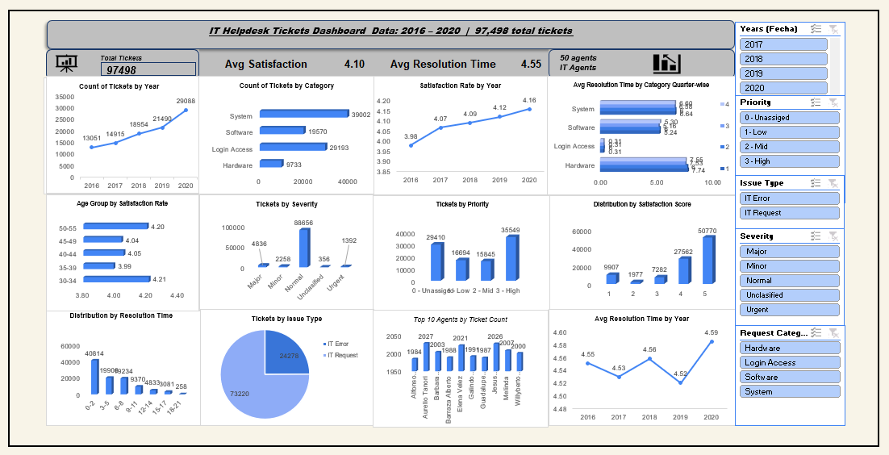

Insights:
• Tickets are growing fast: Looking at the yearly trend, tickets went from 13,051 in 2016 to 29,088 in 2020. That is more than double in just five years, which tells us the team is getting busier every year.
• Hardware is the slowest category: The resolution chart shows Hardware tickets take 7.63 days on average. That is way more than Login Access which takes only 0.31 days. This is a clear area where investment is needed.
• Customers are getting happier: The satisfaction by year chart shows scores went from 3.98 in 2016 to 4.16 in 2020. Even though the team is handling more tickets, they are doing a better job every year.
• Most customers are satisfied: The satisfaction score distribution shows that out of 97,498 tickets, 50,770 received a score of 5. This means more than half of all customers gave the highest possible rating.
• Senior agents work better: The age group chart shows agents aged 50 to 55 have the best satisfaction score of 4.20 and resolve tickets in 4.11 days, which is faster than any other age group.
• Severity classification needs review: The severity chart shows 88,656 tickets are marked as Normal while only 1,392 are Urgent. This seems unbalanced and suggests the severity labels may not be assigned correctly.
Recommendations:
• Fix Hardware delays first: Since Hardware tickets take the longest to resolve, the company should either hire specialized hardware agents or invest in better tools to speed up the process.
• Automate simple Login tickets: Login Access tickets resolve in just 0.31 days because they are simple and repetitive. Adding a self-service reset portal would save agent time for harder problems.
• Use the dashboard every month: Management should review this dashboard in monthly meetings to track performance, catch problems early, and decide where to spend money next.
• Fix how severity is assigned: Since almost all tickets are labeled Normal, the team should create clearer rules for marking tickets as Urgent or Major so that critical issues get faster attention.
• Train younger agents using senior ones: Since older agents perform better, pairing them with younger agents as mentors would help the whole team improve their speed and satisfaction scores.
• Plan ahead for more tickets: Since ticket volume has been growing every year, the company should start planning now whether that means hiring more people or buying better software before the workload becomes unmanageable.
• Focus on reducing resolution time for urgent tickets.

